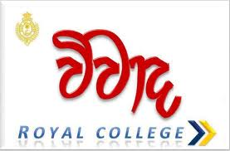
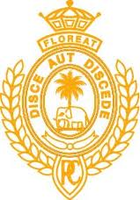 NIMH

All Island interschool debate competition
World mental health day - 2013 October 10

National Institute of mental health with co – compliments of Royal College, Colombo organizes all island interschool debate competition on world mental health day - 2013

* Competition will be opened for all schools.
* Competition will be conducted in 3 stages; each stage will be on different topics.
* Preliminary and semifinal competitions will be held in September 2013 at NIMH & Royal
College, Colombo premises. Final competition will be commenced with world mental health
day celebrations in October 2013.
* Each school can represent with a team of four candidates.
* Participants should be school children, below 19 years of age (Born on or after 1994.01.01)

Application for the above competition should be forwarded through the school’s principals, prepared according to the sample application given below on or before 31st of July 2013, to the Director, NIMH, Mulleriyawa, New town in registered post. Left upper Conner of the envelop should be indicated “Interschool debate competition 2013”

Application for the World mental health day, Interschool debate competition 2013

Name of the School:
Address:
Telephone No:
Fax No:
Participant’s names:
1. .............................
2. .............................
3. .............................
4. …………………

Approval of the Principal: ………………………..
Signature
Wining schools will be awarded with trophies and certificates
Details – NIMH website www.nimh.health.gov.lk , Telephone no 0112578234 – 7
Royal College website www.royalcollege.lk / www.inforoyal.com

National Institute of Mental health, Mulleriyawa new town.
Royal college – Colombo 7.

